TITLE PAGE

Thoughts from Barry Segal

“The Electoral College is Undemocratic”

**Table of Contents**

The Problem with the Electoral College- Thoughts from Barry basic summary of the document

Break Down of the Swing States

Electoral College as a means of Black Voter Suppression

Other means of Black Voter Suppression

AI/ Foreign Interference

USA as a Failed Democracy

What other Democracies Do

Past Attempts to End IT: Constitutional Amendments, National Popular Vote Interstate Compact)

Positive Effect of Discontinuing

**Something is Wrong Here: The Electoral College must be Eliminated.**

I think a lot of what we do I this country makes no sense, but one of the things that has bothered me for a long time is the electoral college. When the Electoral College was established in 1787, the institution was influenced by the political and social dynamics of the time, including the issue of slavery. The system was partly a compromise between large and small states and reflected the interests of slaveholding states. For example, the Three-Fifths Compromise allowed slaves to be counted as three-fifths of a person for both representation and taxation purposes, which indirectly affected the Electoral College. It continues to be used to suppress the impact of minority votes.

Gerrymandering, Electoral College, and Felony Voter Disenfranchisement are all ways to suppress minority votes. These are all political tools to continue to keep power in the hands of the elite. Again, this is not democratic.

In addition to the social changes since the time it was developed, news, social media, and artificial intelligence have changed the way voters receive information. The electoral college places disproportionate power on voters in such few states, making it easier for foreign governments to influence election outcomes.

The electoral college needs to be eliminated but the changes need to be phased in slowly. Obviously, the republicans don’t want this to change, because it is a way the keep power. I believe that if politicians need to attract the majority of popular votes to win an election, they will have to adapt to appeal to more people. This will lead to less political extremism and less polarization among the parties. I believe this is needed if we are to be a united nation.

Barry

**The Electoral College is NOT Democratic**

Democracy is, by one definition, the control of an organization or group by the majority of its members. How does the United States meet the definition of a democracy when the electoral college process puts the power to choose a president in the hands of very few of its citizens?

Through the Electoral College, what state you live in determines the importance of your vote. Therefore, not all votes are measured equally. The value of vote is determined by where you live, because each state is weighed differently by the number of electoral votes they represent. Smaller states have a disproportionately higher influence per voter compared to larger states. States that always vote republican also have the lowest voter turnout. If you are not in a swing state, it could be easy to conclude your vote doesn’t matter.

The current system, often gives white, rural voters more voting power than minorities living in cities. Despite this, it still does not encourage candidates to campaign in rural areas but rather focuses their attention on cities in a smattering of swing states; and, interesting, those swing states receive more federal funds than other states

In the United States, there have been instances of five presidential elections where the winner of the popular vote did not win the presidency, leading to questions about the system's democratic legitimacy. In 2016, Hillary Clinton (Democrat) outpaced President-elect Donald Trump (Republican) by almost 2.9 million votes which is by definition, undemocratic.

Trump lost the popular vote by nearly 2.9 million votes in 2016. Hillary Clinton won 65,844,954 votes which is 48.2%, and Donald Trump won 62,979,879 votes consisting of 46.1% of the popular vote. He never should have been president and to add to the confusion, it gave him the opportunity to go to the states and try to change the outcome of future elections. That’s really stupid.

The public has continuously supported abolishing the electoral college. The Gallup Poll reported in 2001 that “there is little question that the American Public would prefer to dismantle the Electoral College system and go to a direct popular vote for the presidency.

In September 2020, 61 percent of Americans polled by Gallup favored using the popular vote to elect the president. By June of 2022, 65 percent of Americans wanted presidential elections decided by popular vote, and only 32 percent preferred using the electoral college. However, more recently there has been a partisan difference in opinion on the issue. More democrats favor abolishing the electoral college, while fewer Republicans favor it.

I was surprised how long this has bothered me. Back in 2020 we put up a billboard in support of ending the electoral college.

**Break Down of the Swing States**

If you look at the presidential voting patterns of the past 4-5 presidential elections, you will see that many states vote reliably the same way every election. As a result, most states get designated as red states (Republican) or blue states (Democratic). There are only a few states, between 7-11, that become the focus of many elections- **the swing states**- because they can go either red or blue. This system leads presidential candidates to focus disproportionately on the swing states, potentially neglecting the concerns of voters in states with predictable outcomes.

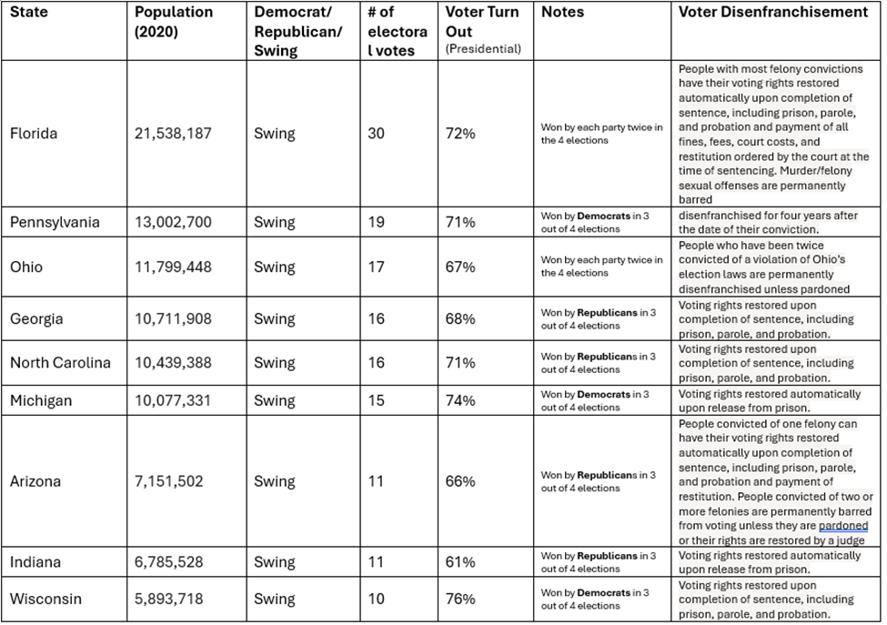

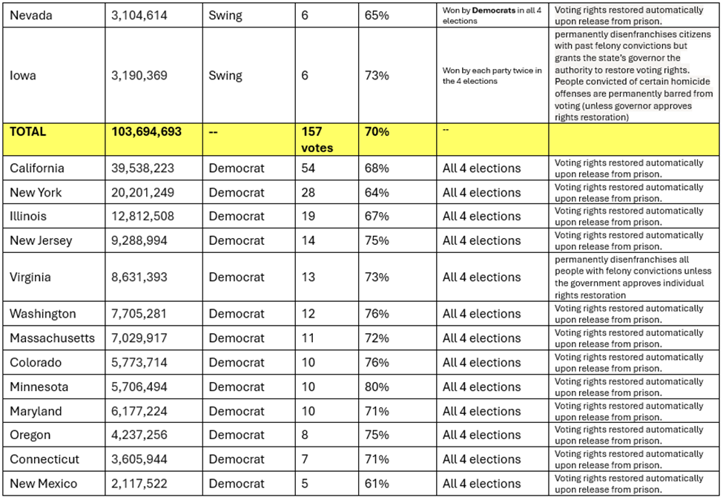

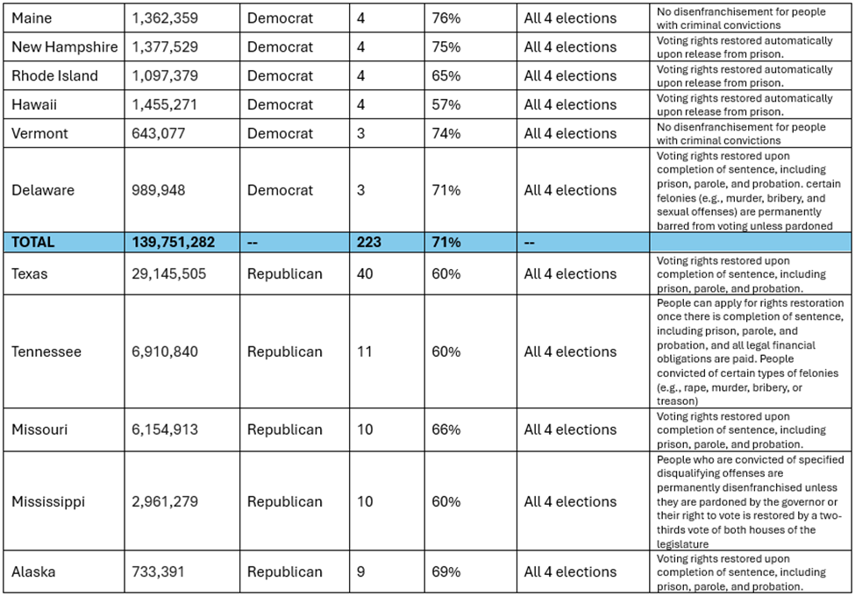

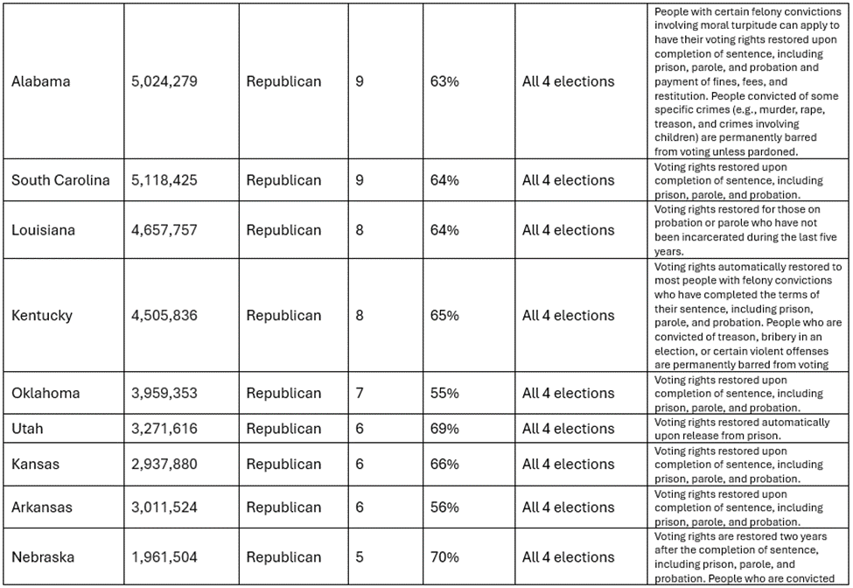

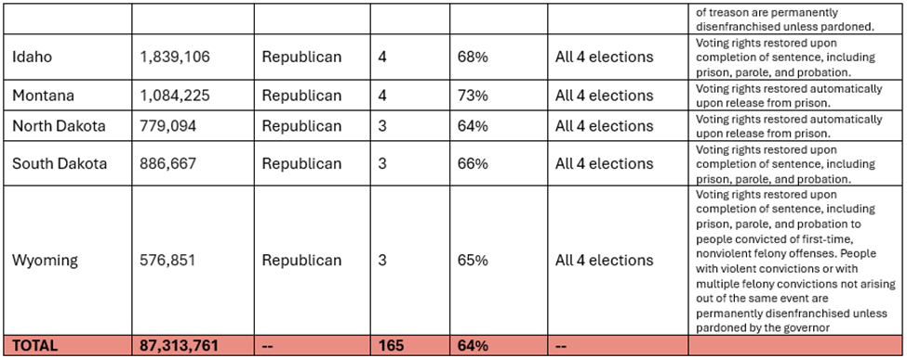

**Electoral College and Black Voter Suppression**

**The problem is simple. Since 1968 approximately**[**80-90 percent of the black vote**](https://press.princeton.edu/ideas/why-are-blacks-democrats)**has gone to one party.**Under the electoral college, with help from political gerrymandering and felony disenfranchisement, black votes are diluted. Republicans understand their power is very dependent on this system continues.

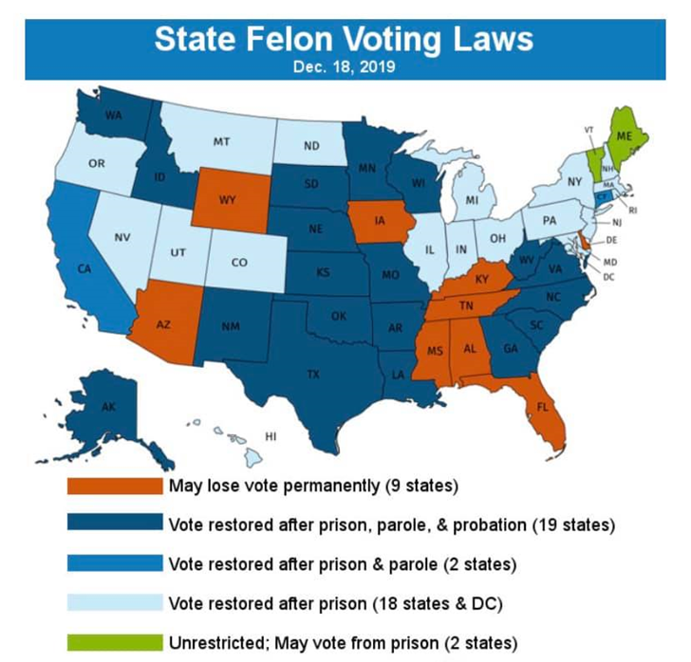

**History of black voter suppression:**

19th and early 20th century-

* Literacy tests-
  + Intertwined with slavery, anti-literacy laws were put into place in the south banning enslaved people from being taught to learn how to read
  + 76% of southern African Americans were illiterate at the time, according to the 1880 census bureau
  + In 1900, 50 percent of voting-age Black men could not read, compared to 12 percent of voting-aged white men.
  + Literacy tests were one of the most effective tools at suppressing the African American vote. The voting clerks, who were always white, could also pass or fail a person at their discretion based on race.
* Poll taxes-
  + Southern legislatures claimed that poll taxes for voting were designed to raise state revenue
  + Eleven states in the South had laws that required citizens to pay a poll tax before they could vote. The taxes, which were $1 to $2 per year, disproportionately impacted Black registered voters
  + Georgia- implemented a cumulative poll tax in 1877 that required all citizens to pay back taxes before being permitted to vote, Black voter turnout went down 50%

**Mass incarceration/mass disenfranchisement-**

* The number of people stripped of their voting rights due to felony convictions went from 1.2 million in 1976 to a high of 6.1 million in 2016- the year Donald Trump won the election
* A pie chart with numbers and text

  Description automatically generatedAbout 2.3%—a total of 5.3 million people—of the American voting age population is disenfranchised because of these felony voter restriction laws, and over 1/3 of these disenfranchised individuals are Black.

Results from a 2017 poll demonstrated that 19% of voters who identified as African American reported instances of racial discrimination when they attempted to vote or participate in politics, as compared to 15% of Latinos, 10% of Native Americans, and 7% of Asians.

* Across the country, 1 in 16 Black[Americans](https://www.sentencingproject.org/publications/locked-out-2020-estimates-of-people-denied-voting-rights-due-to-a-felony-conviction/) cannot vote due to disenfranchisement laws.

**Suppression in the 2020 election:**

* “Republicans have gone to court to make it easier to reject mailed ballots on technicalities. Already, election officials have contested some 6,800 votes–a number bound to grow as more people vote.”
  + North Carolina, about 20% Black; 40% of the contested ballots come from Black voters.
* A group of Michigan voters [has also filed a lawsuit](https://www.politico.com/f/?id=00000175-e895-d27b-a5f7-f895bd7a0000) against Trump and his campaign, arguing that "defendants are openly seeking to disenfranchise Black voters," including those in Detroit.
  + The plaintiffs, who are represented by lawyers from the NAACP Legal Defense Fund, alleged that the Trump campaign has attempted mass voter suppression by pressuring election officials into not certifying the election results in their state
* It is far more difficult for members of minority communities to be able to locate polling places on Election Day.
  + Only 5 percent of white survey respondents reported that they had trouble finding polling locations, compared to 15 percent of African American respondents

**Anti-voting laws in the south now-**

* Georgia- Republican Gov. Brian Kemp signed anti-voting rights bill into law 2021
  + [SB 202](https://www.legis.ga.gov/api/legislation/document/20212022/201121): imposes new voter identification requirements for absentee ballots, allows state officials to take over local election boards, curbs the use of ballot drop boxes and makes it a crime for people who aren’t poll workers to approach voters in line to give them food and water.
* Florida- Republic Gov. Ron DeSantis signs restrictive voting bill
  + [SB 90](https://www.flsenate.gov/Session/Bill/2021/90): imposes stricter voter identification requirements for voting by mail, limits who can pick up and return a voter’s ballot, and prohibits private funding for elections, among other things.
* Voter ID laws- [Thirty-six](https://www.ncsl.org/research/elections-and-campaigns/voter-id.aspx) states have identification requirements at the polls. Seven states have strict photo ID laws, under which voters must present one of a limited set of forms of government-issued photo ID to cast a regular ballot
  + [Over 21 million](https://www.brennancenter.org/sites/default/files/legacy/d/download_file_39242.pdf&sa=D&source=editors&ust=1628279349300000&usg=AOvVaw3-x1Rr7pX1SsbR6ucG_S1z) U.S. citizens do not have qualifying government-issued photo identification, and these individuals are [disproportionately voters of color](https://www.brennancenter.org/our-work/research-reports/new-voter-suppression&sa=D&source=editors&ust=1628279349301000&usg=AOvVaw33lhlANBuQR7ok0rdkRynb).

o Obtaining an ID can be costly and requires an individual’s birth certificate, which may be burdensome.

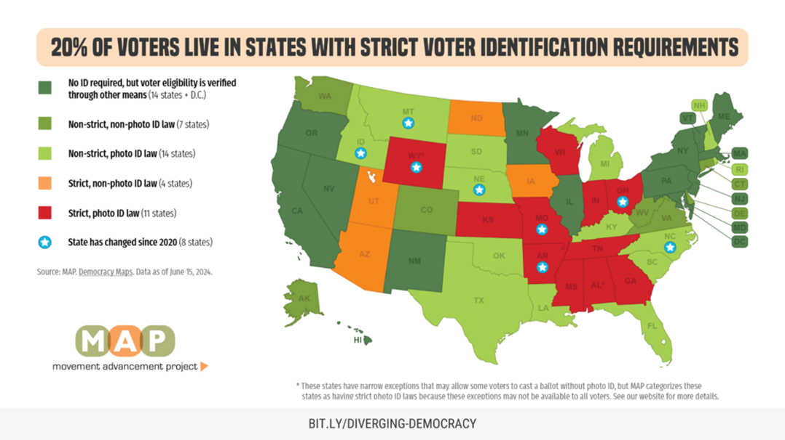

**Wait times for polls-**

* Long lines are estimated to have deterred between 500,000 to 700,000 people from casting their ballot in 2012
* In 2012 and 2016 the average nonwhite voter waited about twice as long as the average white voter
  + A study found those in majority black neighborhoods waited longer
* In a 2016 study, Stein and his colleagues found a specific culprit of these wait times- voter ID laws
  + Areas with minority voters who are less likely to have an ID, tend to be most affected by these laws

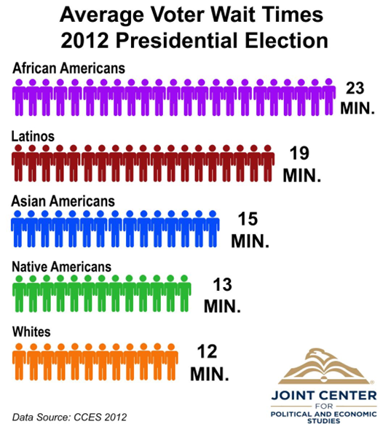

**AI and Foreign Interference**

Using the electoral college makes the susceptibility of foreign powers to manipulate the election process incredibly high. Foreign powers like the Russian government can use social media to very specifically target citizens in states, such as swing states, with information and false information to sway the minds of voters that hold more voting power in swing states. If the popular vote was used to elect the president instead of the electoral college, it would be more difficult for a foreign power to manipulate millions of voters and alter voting systems across the entire nation. Broad-based attacks would be more noticeable, but also more resource-intensive. Whereas, targeting tens of thousands of voters, and hacking into a few hundred voting systems would be easier and less noticeable.

According to an article written by Matthew Olsen and Benjamin Haas in Politico Magazine, “Hamilton and his colleagues never could have envisioned a year like 2016, when an enemy state—Russia—was able to manipulate America’s election process with stunning effectiveness. But it’s clear the national security rationale for the Electoral College is outdated and therefore it should be retired. Simply put, it enables foreign powers to more easily pierce the very shield Hamilton imagined it would be.

In Hamilton’s day, as he argued, it would have been nearly impossible for a hostile power to co-opt dozens of briefly chosen electors flung across 13 states with primitive roads. But in the social media age, the Electoral College system provides ripe microtargeting grounds for foreign actors who intend to sabotage presidential elections via information and disinformation campaigns, as well as by hacking our voting infrastructure. One reason is that citizens in certain states simply have more voting power than citizens in other states, such as Texas and California. This makes it easier for malign outside forces to direct their efforts.

Congressional investigators are currently examining Russia’s 2016 disinformation campaign. Senator Mark Warner of Virginia, the ranking member of the Senate Intelligence Committee, has publicly called out Russian microtargeting in 2016 swing states. In March, Warner [highlighted](http://www.cbsnews.com/news/crucial-senate-intelligence-committee-hearings-on-russian-role-in-u-s-elections-on-tap/) reports of “upwards of 1,000 paid internet trolls working out of a facility in Russia, in effect, taking over series of computers, which is then called a botnet,” and he raised the question of whether these trolls targeted voters in Wisconsin, Michigan and Pennsylvania. Donald Trump, of course, [won](https://www.washingtonpost.com/news/the-fix/wp/2016/12/01/donald-trump-will-be-president-thanks-to-80000-people-in-three-states/?utm_term=.2589f0ce04d9) those three states by a combined total of fewer than 80,000 votes, securing him an Electoral College victory and a four-year trip to the Oval Office, despite [losing](http://abcnews.go.com/Politics/hillary-clinton-officially-wins-popular-vote-29-million/story?id=44354341) the national popular vote by nearly 3 million votes.

And choosing the right voters to target is not a task that requires domestic assistance. As Issie Lapowsky of *Wired* recently [explained](https://www.wired.com/story/russia-trump-targeting-fake-news/), “there’s nothing preventing a Russian actor or anyone else from reading the news and understanding the American electorate, and thanks to readily available digital tools, targeting that electorate is simple.”

Protecting U.S. elections from foreign interference is a legitimate national security concern that all Americans should be able to embrace. Both state and nonstate actors may have an interest in influencing our future elections, and there’s no telling right now [which](http://www.npr.org/2016/10/19/498529403/marco-rubio-warns-gop-on-wikileaks-tomorrow-it-could-be-us) presidential candidates they will prefer. In addition, although Russia clearly favored Trump in the 2016 election, it also demonstrated its willingness to gather ammunition on Republicans.

**The US as a FLAWED DEMOCRACY**

The EIU’s 2023 Democracy Index ranked the US as an example of a flawed democracy. Flawed democracies are nations where elections are fair and free and basic civil liberties are honored but may have issues (e.g. media freedom infringement and minor suppression of political opposition and critics). These nations can have significant faults in other democratic aspects, including underdeveloped political culture, low levels of participation in politics, and issues in the functioning of governance.

**Democracy and Different Countries**

The United States has been the only democracy in the 21st century that still uses an electoral college to select its executive president. The other democracies that used an electoral college for these elections switched to direct elections in the 19th or 20th century. There are 11 countries that use an Electoral College system, but they are not considered Democracies.

**Federal Republic of Germany** is considered a full democracy

* Federal, parliamentary. Representative democratic republic
* National Parliament consisting of the Bundestag (Federal Diet) elected and Bundesrat (Federal Council) - together form the legislative body and are elected through direct local elections with a tier of party list votes
* President is head of state and is elected by the citizens via an election
* Chancellor (similar to a Prime Minister) is head of government and is elected by the Bundestag

**France** is considered a full democracy

* unitary semi-presidential republic with a bicameral legislature
* The president exists alongside a prime minister and is directly elected by the citizens via popular vote.
* The Parliament (consisting of the National Assembly and Senate) are also elected directly by citizens. The Senate has an electoral college to elect 328 of the 348 members of senate
* The Prime Minister is appointed by the president.

**Government of the United Kingdom** is considered a full democracy

* Constitutional Monarchy
* A hereditary monarch serves as head of state
* Prime Minister is the leader of the government
* The Prime Minister is the leader of the party that wins the most seats at a general election. After a general election the monarch calls upon the leader of the largest party to form the Government
* The Prime Minister selects ministers, and they make up The Cabinet
* Ministers of the Crown are responsible to the House
* Members of Parliament are elected by popular vote
  + American Bar Association explains that Voter ID laws have underlying racial biases and prevent minorities from engaging in active democratic participation. These requirements compel an individual to present his or her ID in order to cast a ballot on Election Day.

**Attempts to Eliminate the Electoral College**

In 1969, the House passed a constitutional amendment to establish direct election of the president by a bipartisan vote of [338 to 70](https://www.history.com/news/electoral-college-nearly-abolished-thurmond). The bill passed the Senate Judiciary Committee by a vote of 11 to 6 and reached the floor in September 1970. There it met a prolonged filibuster from southern senators, who did not want the president to be elected by a popular vote. Therefore, the bill died. Its death was not the result of opposition from small states, however. Instead, **it was the issue of race and the political power of the South that had killed reform.**

Many states have joined a movement to move towards a popular vote system, including NJ. New Jersey is a member of the **National Popular Vote Interstate Compact (NPVIC).** This compact is an agreement among participating states to award their electoral votes to the candidate who wins the national popular vote, but only once enough states join the compact to reach a majority of electoral votes (270). Participants in this compact argue this system better reflects the democratic will of the electorate compared to the current Electoral College system.

In order for a presidential candidate to win the presidency, they need to win the majority of electoral votes which is 270 votes out of the total of 538 electoral votes. For National Popular Vote Interstate Compact to instate the National Popular Vote Law, there needs to be at least 270 electoral votes participating in the compact to ensure that the popular vote will be used as the way we elect the president. Currently, there are only 17 states that have enacted the National Popular Vote Law, totaling 209 electoral votes. These states include California, Washington, Oregon, Colorado, New Mexico, Minnesota, Illinois, Maine, Vermont, New York, New Jersey, Massachusetts, Connecticut, Rhode Island, Maryland, Delaware, and Hawaii. There are four additional states pending the enactment of the bill into law for National Popular Vote, and they are Nevada, Michigan, Virginia and North Carolina. These 4 states total an additional 50 electoral votes to the present 209. After these states enact the bill into law it would leave a total of 259 electoral votes in the compact agreement that they would give their electoral votes to the presidential candidate that wins the national popular vote.

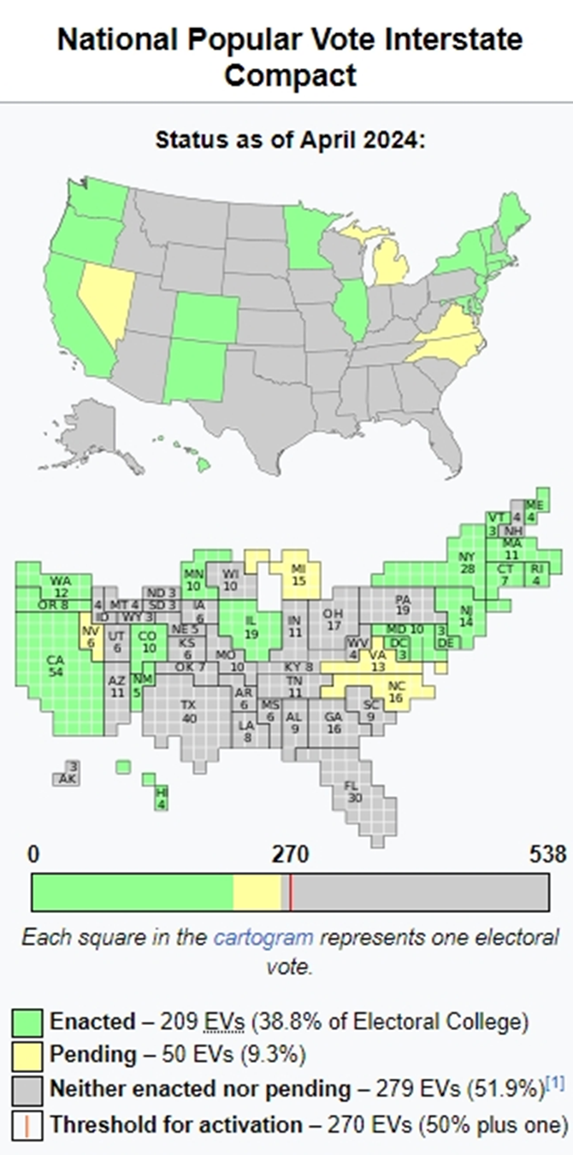

**Positive Effect of Discontinuing**

In order to exist as a truly democratic government, we must ensure equitable representation and eliminate systems that result in voter suppression. Transitioning to a direct popular vote system would allow for several things to happen:

**Equal Voting Power**: A direct popular vote would ensure that every vote has the same weight regardless of where it is cast. This would address concerns about disproportionate influence that certain states or regions have.

**Reflecting the Popular Will**: The candidate who wins the most votes nationwide would become President, which might better reflect the overall will of the American electorate. This would eliminate the possibility of a candidate winning the presidency without popular support.

**Reducing Focus on Swing States**: Presidential campaigns would likely shift focus from swing states to nationwide outreach. Candidates would need to appeal to voters across the entire country rather than concentrating efforts on a few battleground states.

**Increased Voter Engagement**: With a system where every vote counts equally, there could be increased voter engagement and participation. Many people who are in certain states might not feel their vote matters and are less likely to engage in the process.

**Addressing Historical and Systemic Issues:** Eliminating the Electoral College could address some historical issues of racial and regional disparities in voting power. It could reduce the effects of gerrymandering and other practices that can disenfranchise minority voters. It also sends a strong message that we as a nation are looking to eliminate areas of systemic racism.

**Decrease extremism and political polarization:** Both parties now have a vested interest in appealing to all voters. This will lead to people making more accommodations and concessions to get votes.

**WHO IS BARRY SEGAL**